BASH SCRIPT TASK
To create a Script
I used vi to create a a test file and wrote three commands
Free -m
Ps -ef
Df
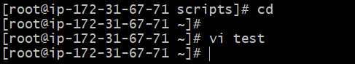
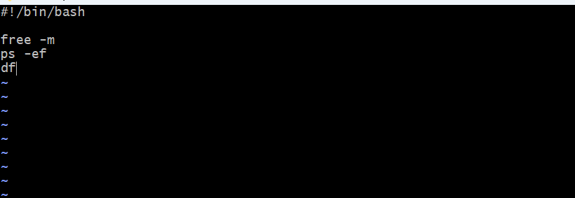
I have added execute permissions in order to execute
Chmod 777 test
To execute the script I have used below command
./test
Bash scripting : Instead of executing commands manually I have automated this process without any manual intervention where the given commands are executed.
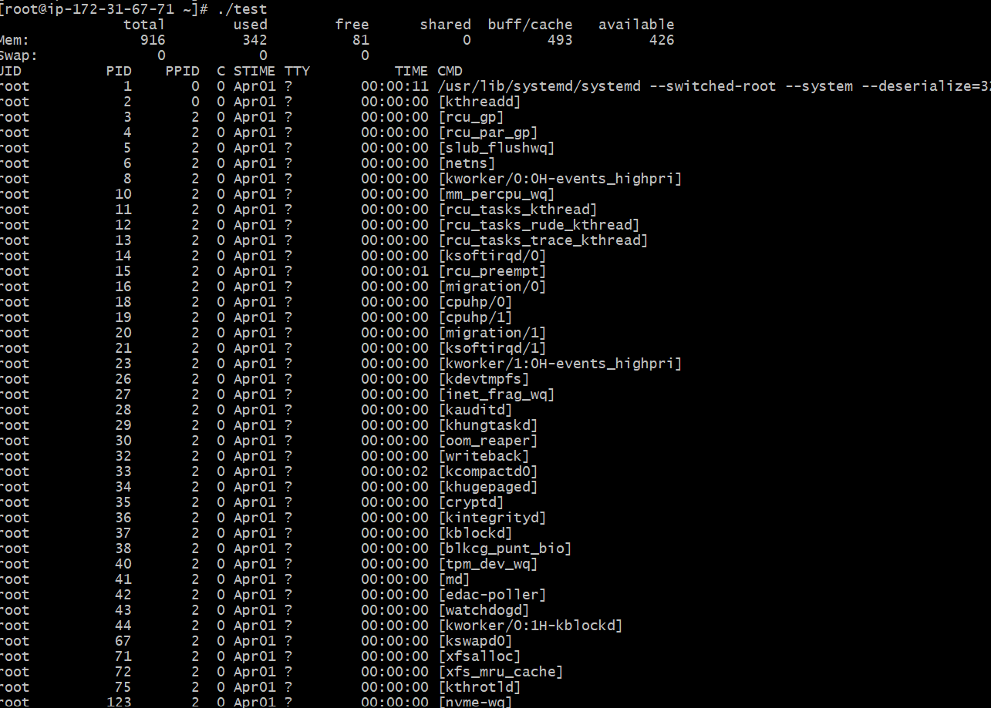
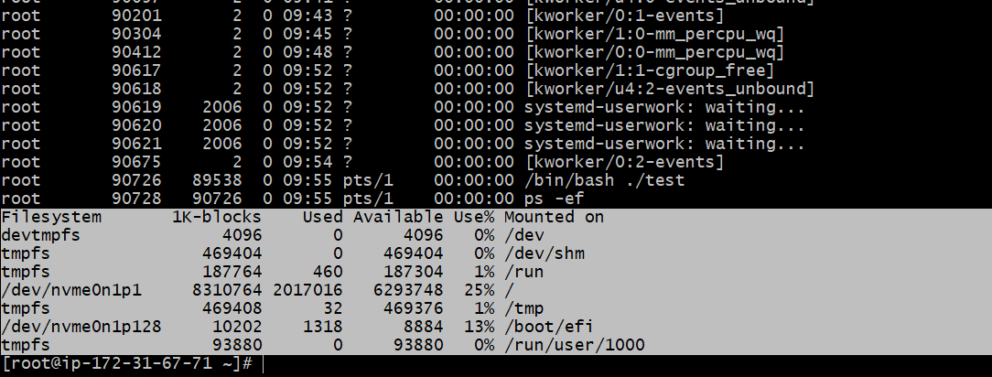

Shell
Shell is an interface between users and kernel / OS
To find shell
Echo $0 – which shell we are using
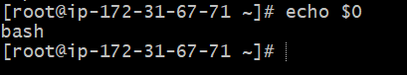
Cat /etc/shells – list of shells which are available
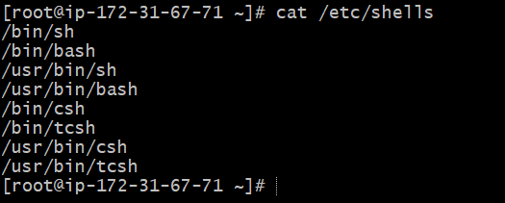
Cat /etc/passwd – To know which user is assigned with which shell
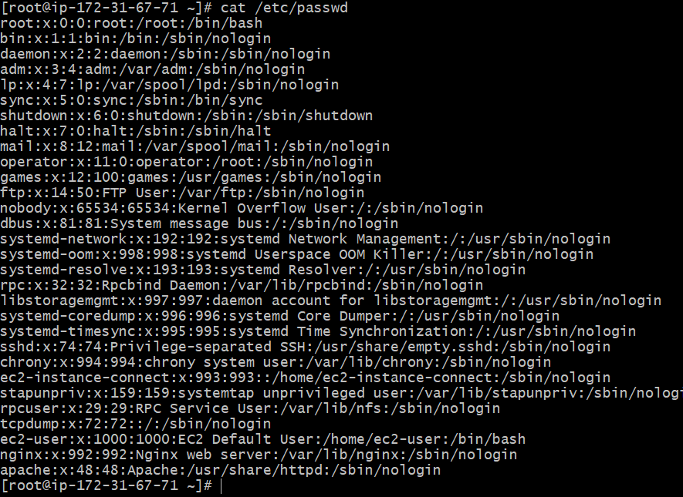
To switch to any particular shell
- I am switching to csh, I gave csh and enter
- Next I have checked using echo $
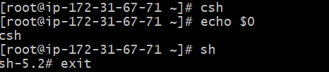
Absolute Path : It gives complete location of a file or directory from the root directory.
I have created directory called scripts
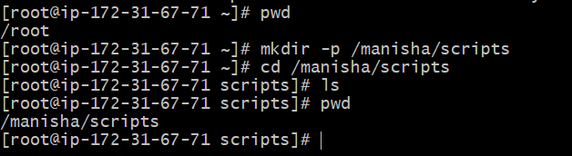
I have created script called Hello World
I have created script using echo as a command
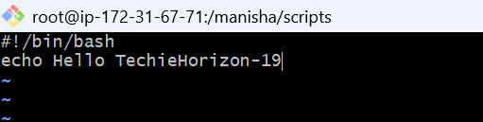
To change the permissions I used command called chmod 777 where I am giving whole permissions.
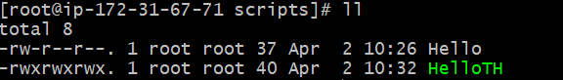
To display the message which is configured in echo I have used below command
./HelloTH
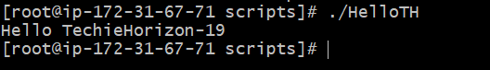
To check the location of the script I have used pwd
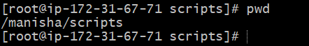
Relative Path : It specifies the location of a file relative to our current directory
I have executed script from root location and passed the directories and scriptname name to get into relative path.
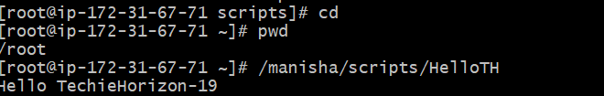
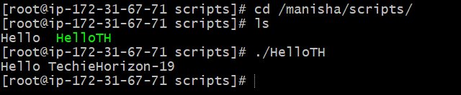
To read the content of HelloTH
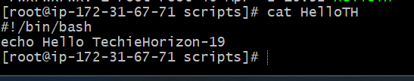

Create an extension for script
To identify it is a bash script we need to create an extension.Here I have used the command
mv HelloTH HelloTH.bash
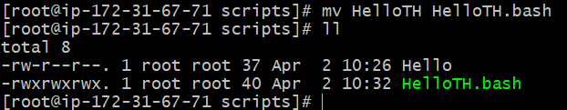
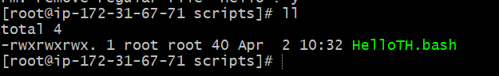
Script File Permissions:
All scripts to be executed should have proper executable file permissions
- I have created a bash name mani.bash
- I have given the permissions as 755
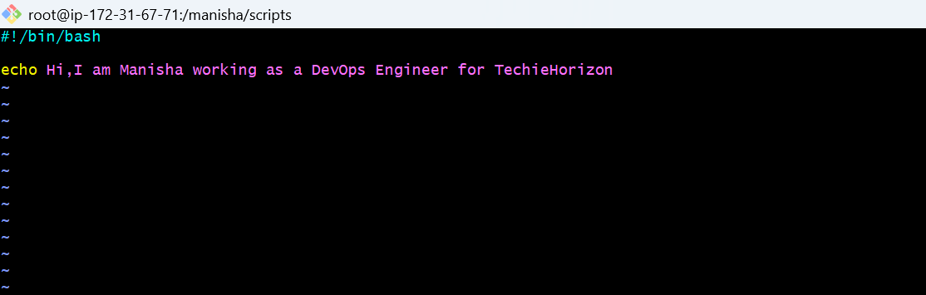
I gave the permissions to manu.bash
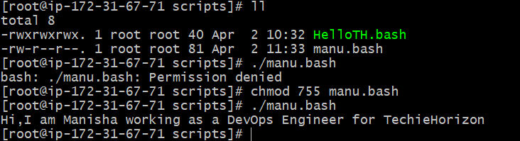
Bash manu.bash- It will directly execute without checking any permissions
Script Format:
According to script format I have created a script below
vi HelloTH
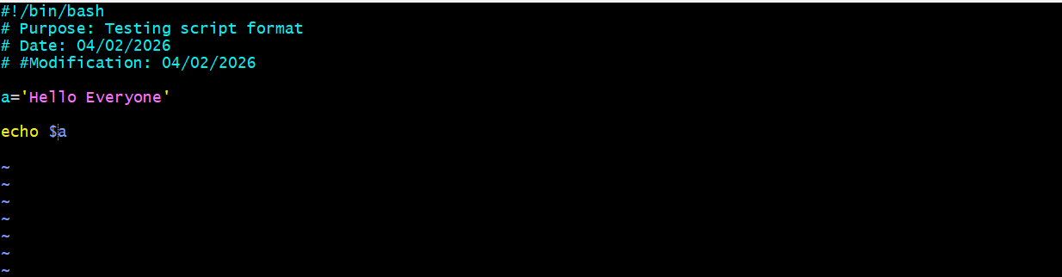
./HelloTH.bash – To get the output
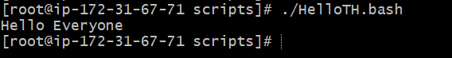
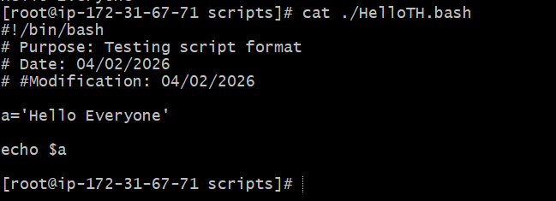

I have created a script with the name commands and gave some commands inside it
I gave permissions to that script.
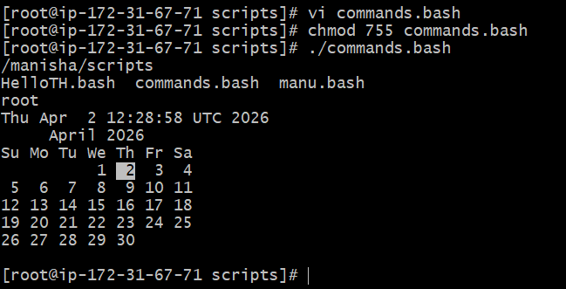
I have created one more scripts as admin.bash with some commands
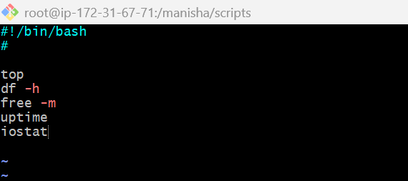
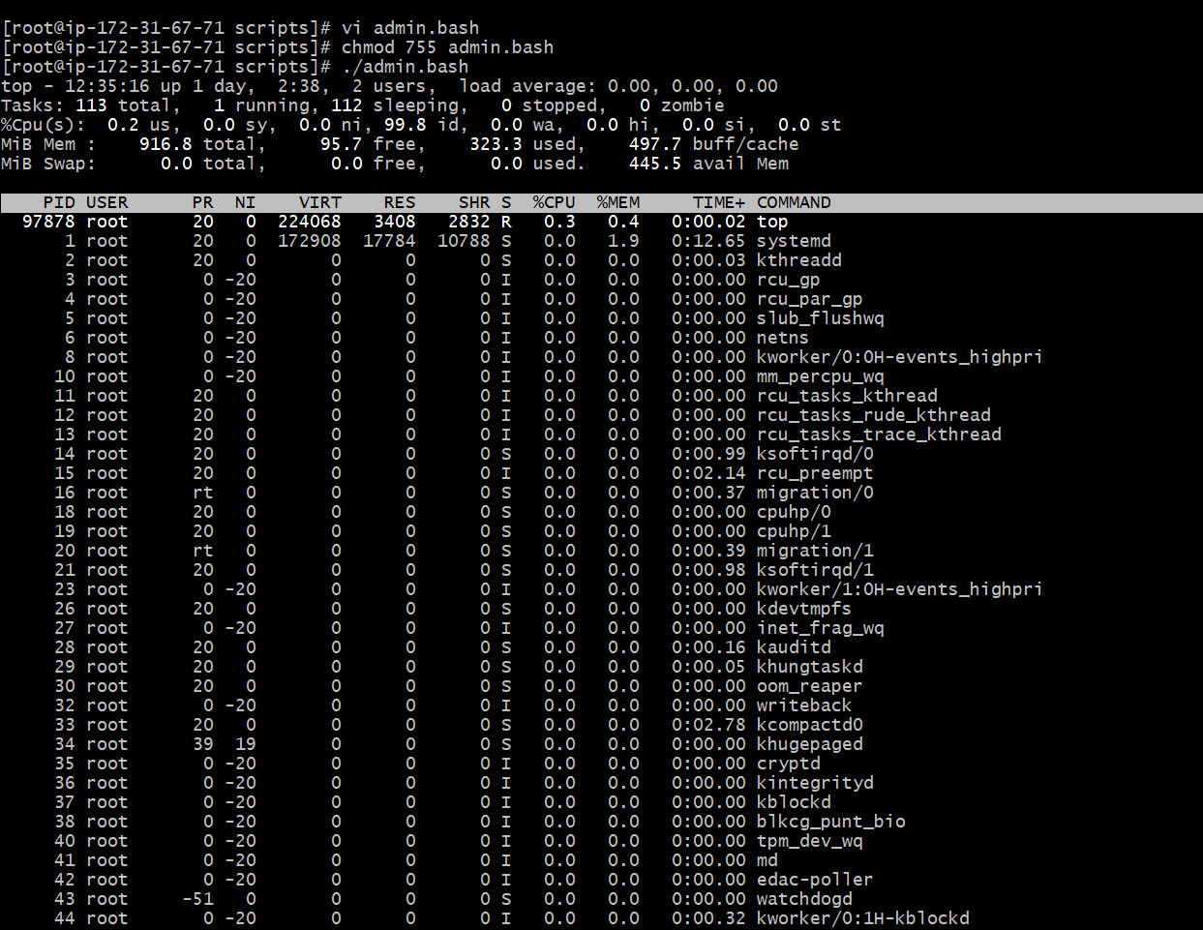
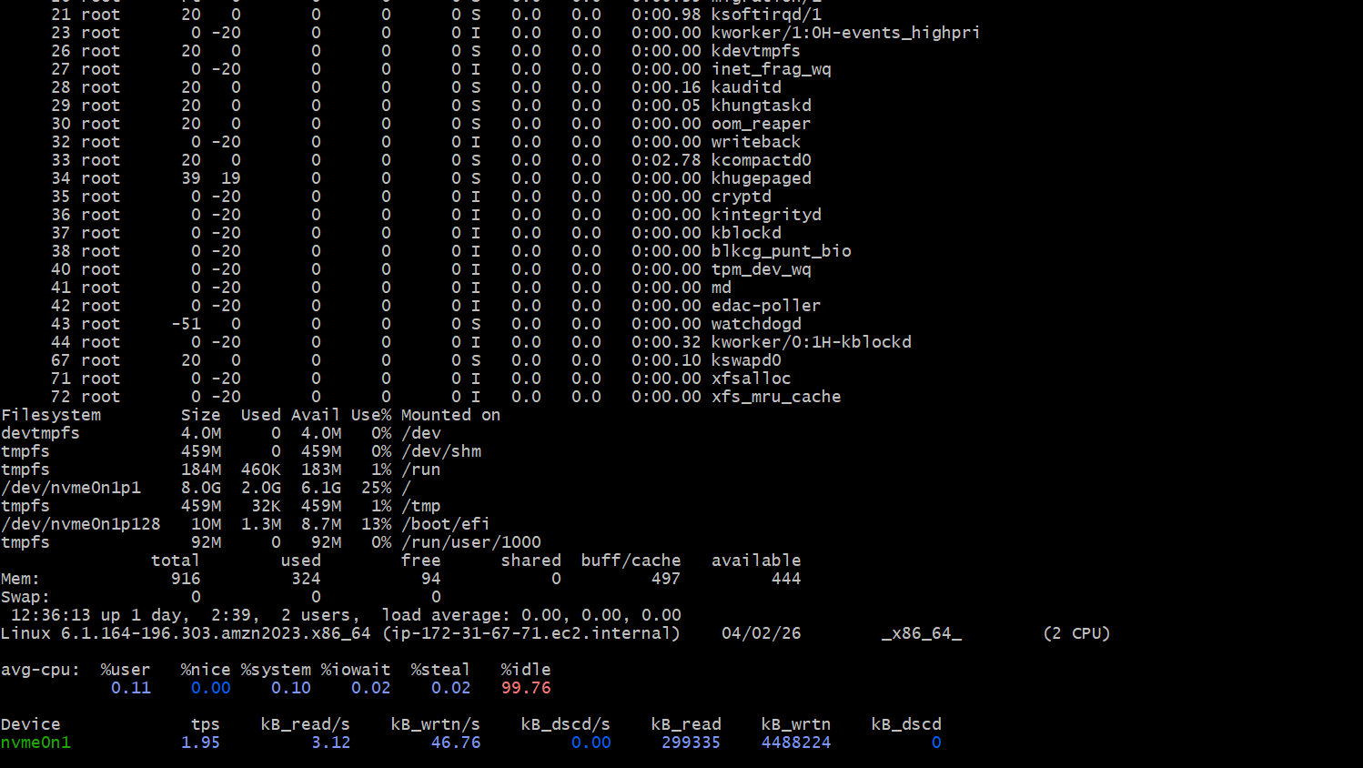
Here I am executing in terms of variable. I have created a script as variables.bash
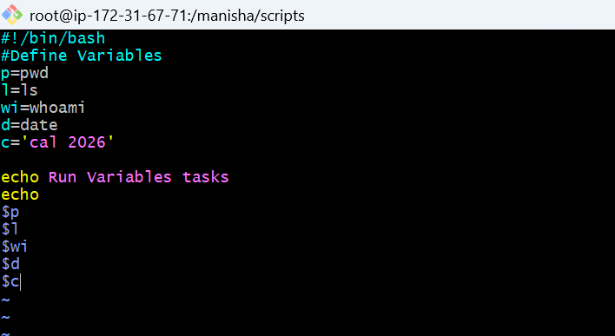
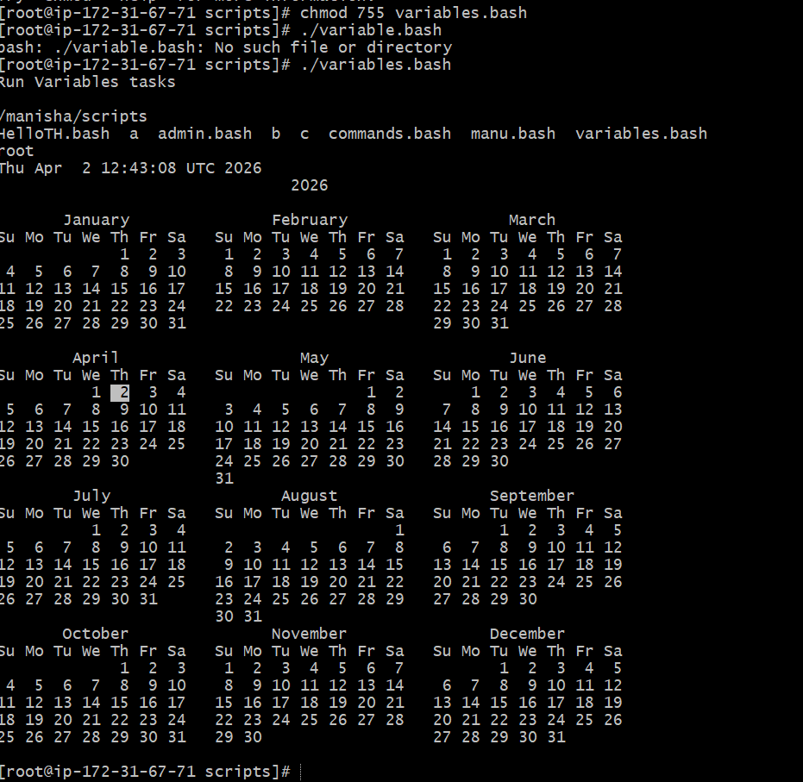

Input.bash
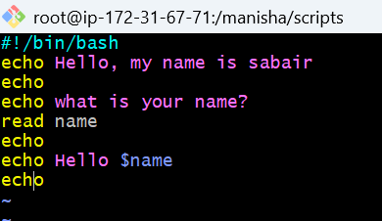
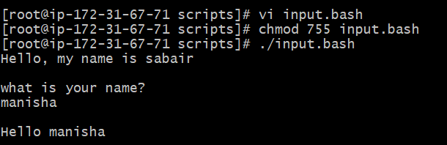

TASK -03

Simple hello world
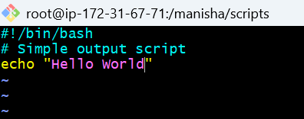
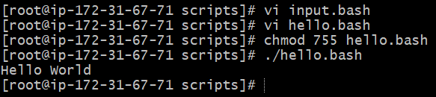

Defining Tasks
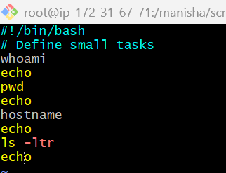
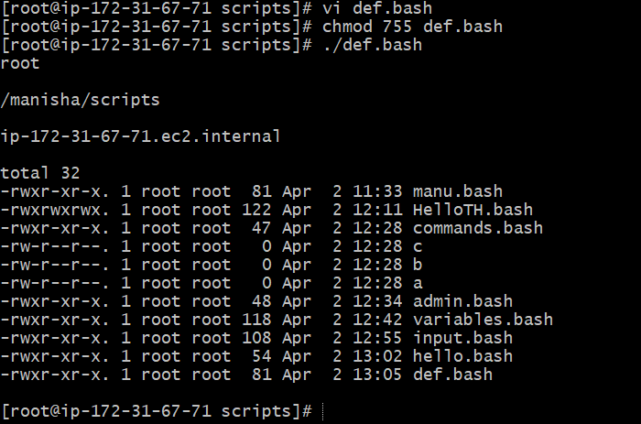
Defining variables
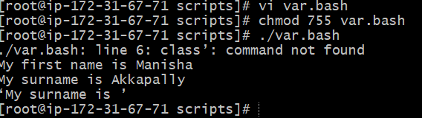
Read Input
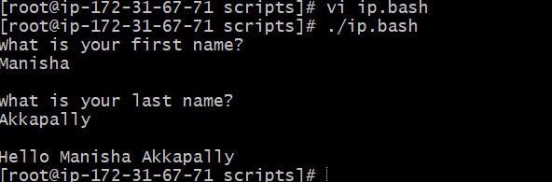
Scripts to run commands within
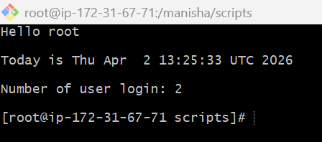

Read input and perform a task
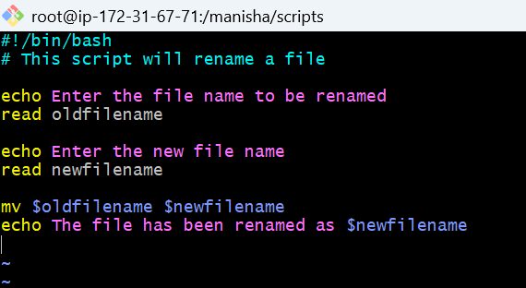
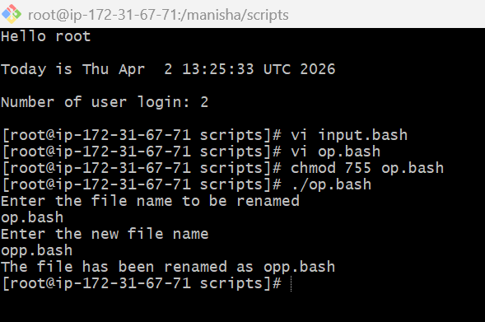

case Scripts:
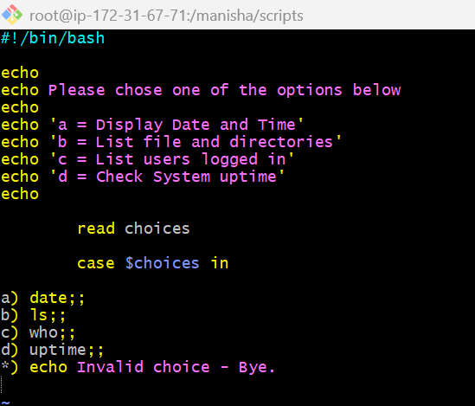
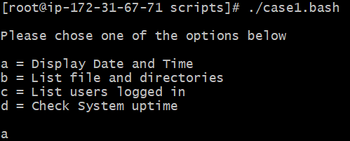
This script will look at your current day and tell you the state of the backup
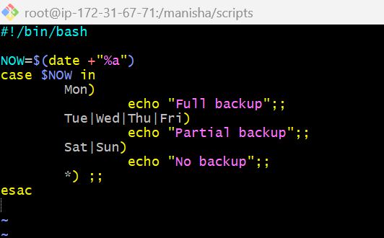
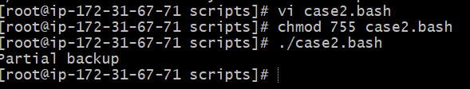
Do while scripts
Script to run for a number of times
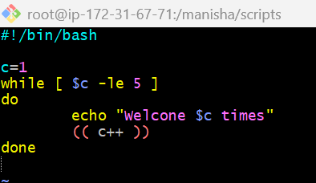
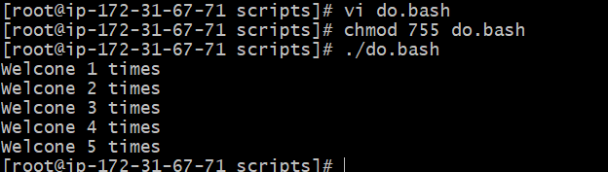
Script to run for a number of seconds
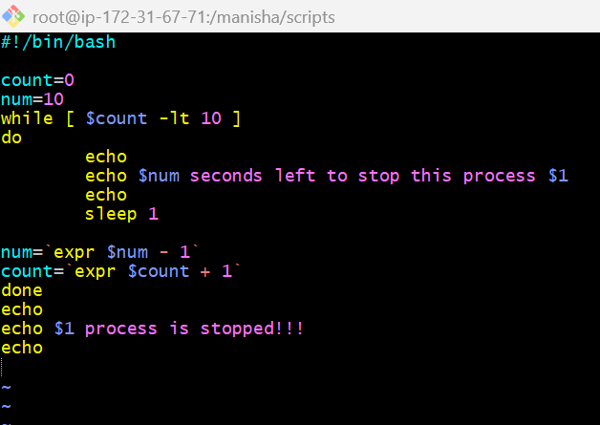
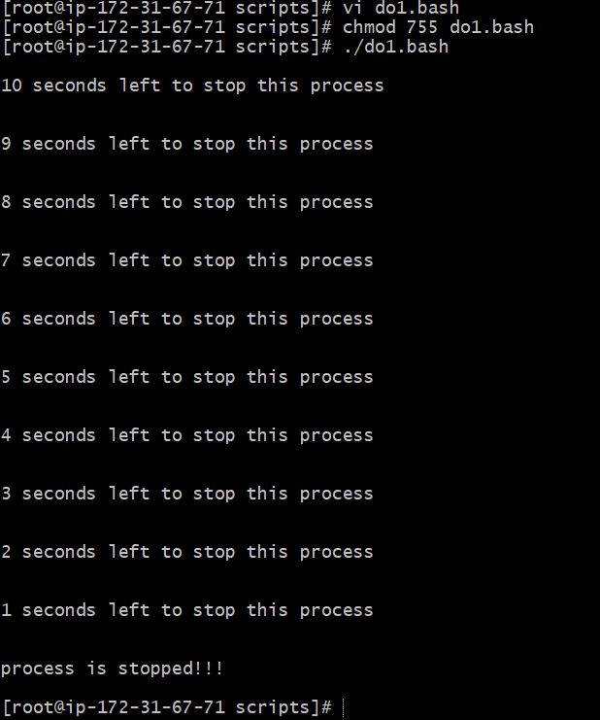

For Loop Scripts
Simple for loop output
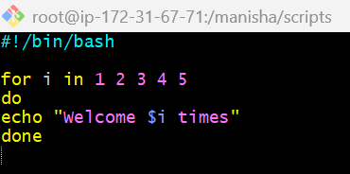
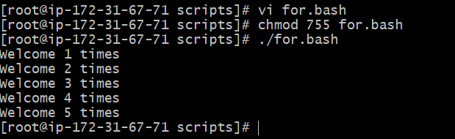
Simple for loop output
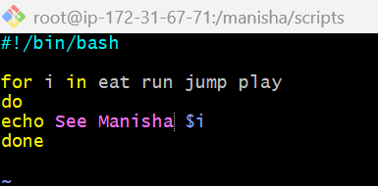
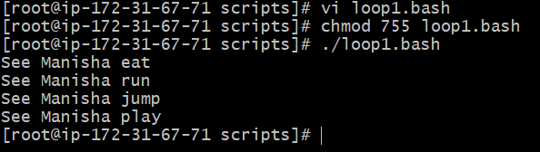
for loop to create 5 files named 1-5
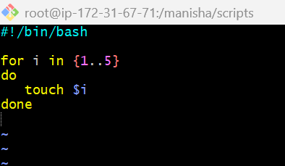
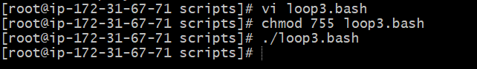
for loop to delete 5 files named 1-5
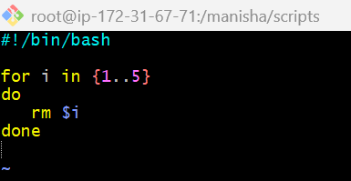
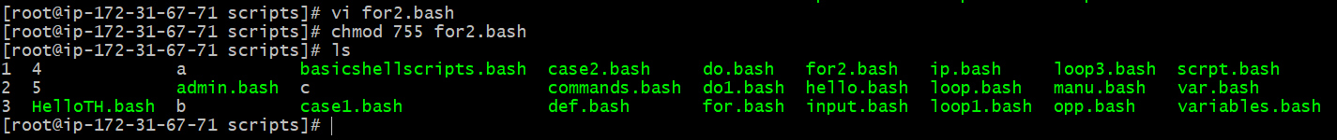
Specify days in for loop
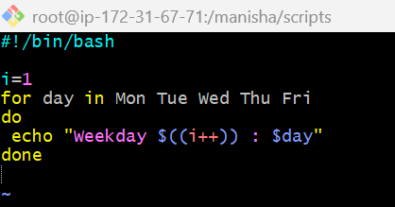
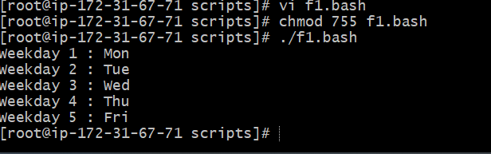
List all users one by one from /etc/passwd file
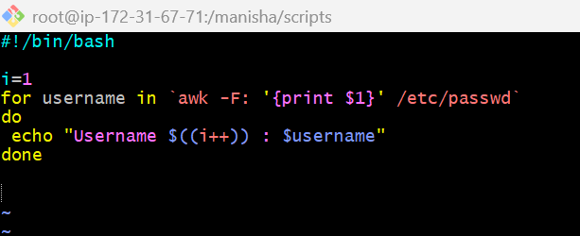
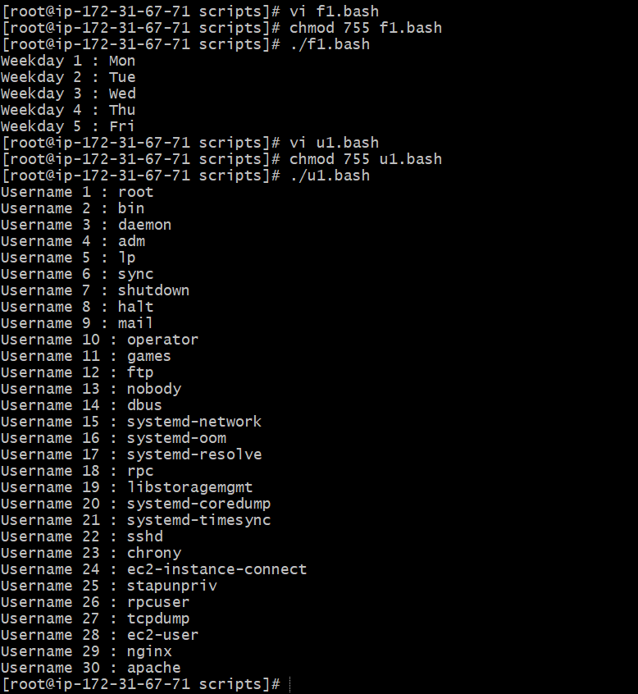
If-then Scripts:
Check the variable
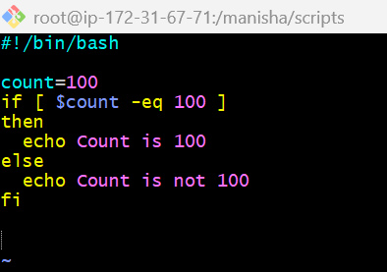
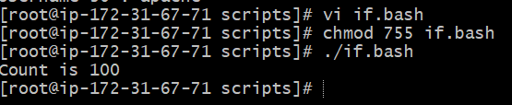
Check if a file error.txt exist
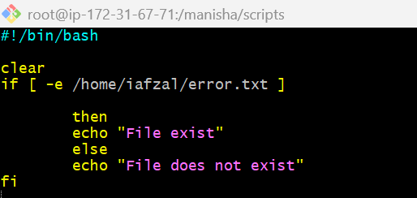
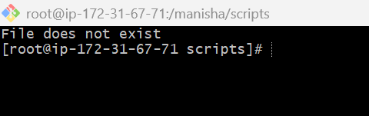
Check if a variable value is met
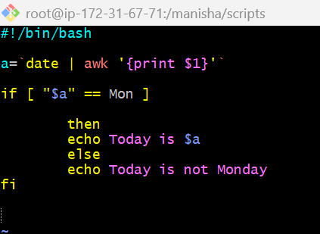
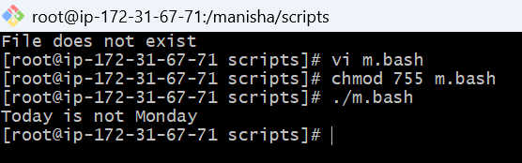
Check the response and then output
